Go to *Chart Review* > in the *Snap shot* search bar type “Pain” > select “Pain / Procedural Support Plan”



If the patient has an existing Pain / Procedural Support Plan, it will look like this:

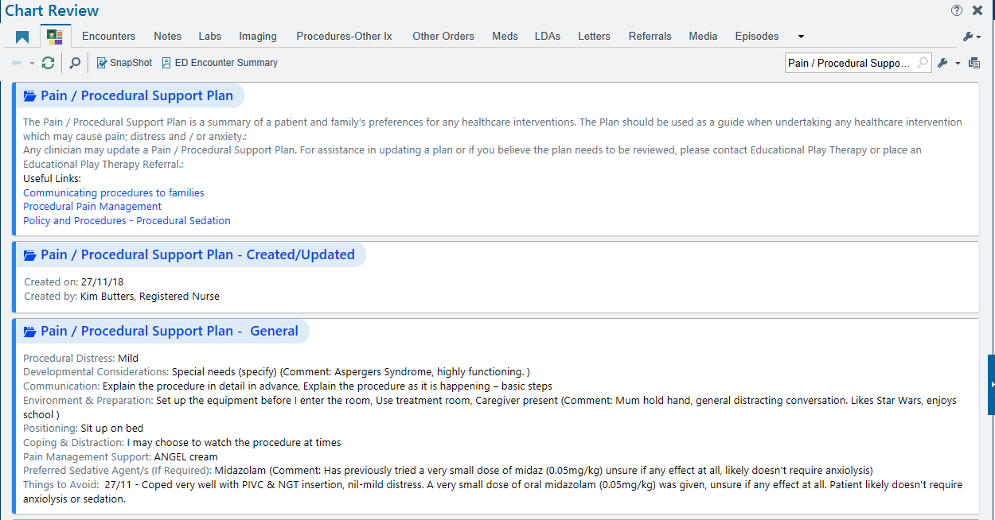

If the patient doesn’t have an existing Pain / Procedural Support Plan, you will be able to edit by clicking on the icon below (all staff can do this):

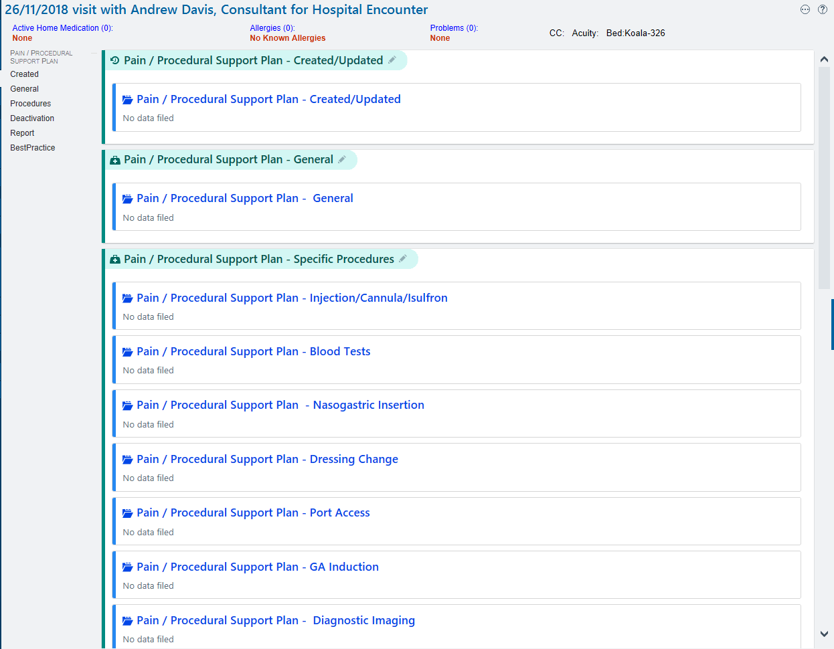

You will then be able to create a new Pain / Procedural Support Plan and press close:

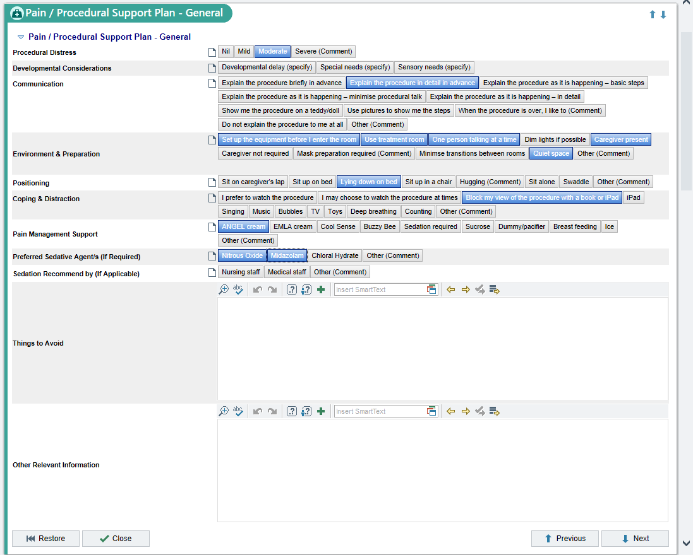

Once a Pain / Procedural Support Plan has been created, it will be filed as an FYI